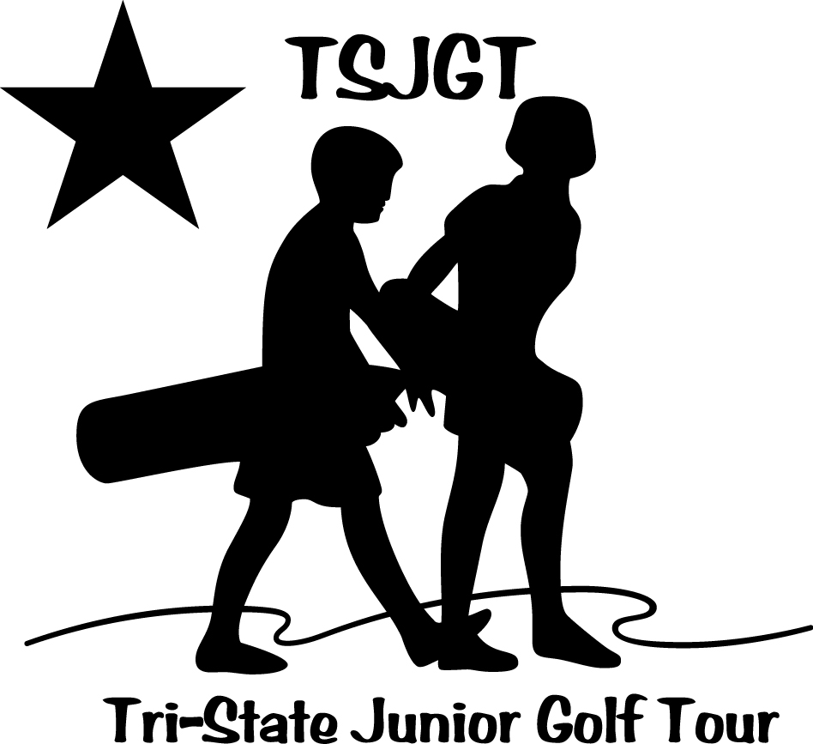
TRI-STATE JUNIOR GOLF ASSOCIATION
2017 Annual Report
The Tri-State Junior Golf Association program celebrated its 26th anniversary in 2017, and continues to serve as a stepping stone for young golfers from the Tri-State area who wish to enjoy golf competition, and/or gain more competitive experience in order to move on to larger tournaments.
The program was co-sponsored in 2017 by Breakfast Optimist Club, Little People’s, Refreshment Services Pepsi and KHQA TV. Breakfast Optimist Club and Little People’s donated $500 each, while KHQA-TV provided special pre-tournament and tournament coverage of each event, and Refreshment Services Pepsi provided soft drinks for contestants at each event.
Players in the 2017 Tri-State events received lunch at each tournament, and USGA Rules Books were available to them. Trophies were given for 1st, 2nd, and 3rd in each division. The schedule for 2017 consisted of six tournaments. After all six events, an overall point winner in each division was awarded a trophy. Each contestant who entered all six tournaments received the opportunity for a scholarship from the Tri-State program to play in the 2018 Pepsi Little People’s Golf Championships.
The TSJGT Scholarship program was established following the 2009 events, and provides qualifying TSJGT players with paid-for entry into the Pepsi Little People’s Golf Championships. Eight players qualified for the 2010 event, while four qualified for the 2011 tournament, four qualified for the 2012 event, five qualified for the 2013 Little People’s, five qualified for the 2014 tournament, three qualified for the 2015, five qualified for 2016 Pepsi tournament, four for 2017 and six for 2018. Winners are drawn from the contestant base, since scholarships cannot be based on golfing ability. It is hoped that these scholarships will encourage more participation in both the TSJGA tournaments and more local participation in Pepsi Little People’s.
The 2017 tournaments were held at Westview Golf Course in Quincy, Rolling Greens Golf Course in Mt. Sterling, Norwoods Golf Club in Hannibal, Spring Lake Country Club in Quincy, Schaeffer Memorial Golf Park in Ft. Madison, IA., and Quincy Country Club in Quincy. Entries in 2011 averaged around 25 players per event. Entries in 2012 averaged 42 players per event, entries for 2013 averaged 36 players and entries in 2014 averaged 33 players. There was an average of 38 players for 2015, 40 players in 2016 and 40 players in 2017.
“We had a great year in 2017,” said Tournament Director Lindsay Burry. “It’s fun to see so many kids in our area who are interested in golf. Not only does the TSJGT provide players with opportunities to make friends and learn the game, but it also gives them some tournament experience. Golf can teach many valuable lessons, so it’s awesome that we are able to get kids involved so young,” added Burry.
In 2018, the TSJGT will again be co-sponsored by Little People’s, Quincy Breakfast Optimist Club, Refreshment Services Pepsi and KHQA TV. Various others will sponsor the lunches after each event.
Stephanie Burry took over the duties as Tournament Director of the Tri-State Tour in 2012, but resigned because of her move to Wisconsin to be with her husband. Daughter Lindsay Burry took over TSJGT duties in 2017, and was assisted by Mike Wensing. Blaise Haxel, assisted by Mike Wensing, is Tournament Director of the Tri-State in 2018, and has scheduled a record eight events, including a final Race for the Tri-State Cup.
(Please note the new TSJGT logo, above)

